*Utilizes nonparametric statistical tests, such as the Sign Test, Wilcoxon Rank Sum Test, the Kruskal-Wallis test, and Spearman’s Rank Order Correlation Coefficient, to accept or reject various statistical claims.*

**Assignment**

**5**

A5

ALY6015 Intermediate Analytics

Assignment 5 – Nonparametric Statistical Methods

**PREPERATION:**

By: John DiSessa

For: Professor Goulding

On: October 30th, 2021

Introduction

My goal was to demonstrate my ability to use nonparametric tests in order to accept or reject certain statistical claims. The questions from the assignment allowed me to demonstrate my ability to use statistical methods, in R, to provide concrete answers in plain English with the data to support my decisions. I used the Sign Test, Wilcoxon Rank Sum Test, Kruskal-Wallis test, and Spearman’s Rank Order Correlation to analyze the following claims.

Section 13-2 Question 6

Game Attendance

**State the hypotheses and identify the claim.**

H0: median attendance = 3000 (Claim)

Ha: median attendance ≠ 3000

**Find the critical value(s).**

* n = 20
* α = .05
* Two-Tailed Test
* Critical Value = 5 (Sign Test CV Table)

**Compute the test value.**

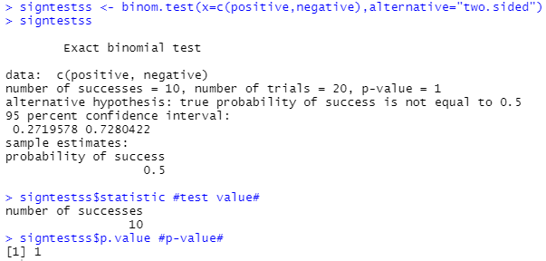

* Test Value = 10
* P-Value = 1

**Make the decision.**

* Test Value (10) > Critical Value (5)
* P-Value (1) > α (.05)
* Fail to reject the null hypothesis

**Summarize the results.**

An athletic director claimed their median number of paid attendances at 20 local football games was 3,000 people per game. We used a Sign Test based on the 20 data points to compare the critical value to the test value and compare the p-value to our alpha. Since we failed to reject the hypothesis, we can say the median number of paid attendances is not different from 3,000. I would feel very confident in using 3,000 as a guide for printing programs.

Section 13-2 Question 10

Lottery Ticket Sales

**State the hypotheses and identify the claim.**

H0: median tickets sold per day ≥ 200

Ha: median ticket sold per day < 200 (Claim)

**Find the critical value(s).**

* n = 40
* α = .05
* 15 Days < 200
* 25 Days ≥ 200
* X = 15
* Left-Tailed Test
* Critical Value = -1.64 (Z table)

**Compute the test value.**



* Test Value = -1.42

**Make the decision.**

* Test Value (-1.42) > Critical Value (-1.64)
* Fail to reject the null hypothesis

**Summarize the results.**

A lottery outlet owner hypothesized that she sells 200 lottery tickets a day. We used a Sign Test to compare how many days sales were above and below 200 tickets. Since we failed to reject the null hypothesis, we can say the median number of tickets sold per day is 200 or more.

Section 13-3 Question 4

Length of Prison Sentences

**State the hypotheses and identify the claim.**

H0: no difference in prison sentence length by gender (Claim)

Ha: difference in prison length by gender

**Find the critical value(s).**

* α = .05
* Two-Tailed Test
* Critical Values = ± 1.96 (Z table)

**Compute the test value.**

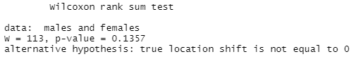

* Test Value = 113
* P-Value = .14

**Make the decision.**

* Test Value (113) > Critical Value (1.96)
* P-Value (.14) > α (.05)
* Fail to reject the null hypothesis

**Summarize the results.**

Prisoners were randomly sampled and asked about the length of the prison sentences in months. We used a Wilcoxon Rank Sum Test to compare the mean prison sentences between males and females. Since we failed to reject the null hypothesis, we can say that there is no difference in prison sentence durations between genders.

Section 13-3 Question 8

Winning Baseball Games

**State the hypotheses and identify the claim.**

H0: no difference wins by league

Ha: difference in wins by league (Claim)

**Find the critical value(s).**

* α = .05
* Two-Tailed Test
* Critical Values = ± 1.96 (Z table)

**Compute the test value.**

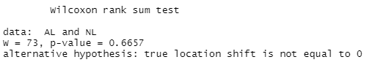

* Test Value = 73
* P-Value = .67

**Make the decision.**

* Test Value (73) > Critical Value (1.96)
* P-Value (.67) > α (.05)
* Fail to reject the null hypothesis

**Summarize the results.**

The American (AL) and National (NL) league’s teams in the Eastern division were randomly sampled for wins per year between 1970 and 1993. We used a Wilcoxon Rank Sum Test to compare the mean wins between leagues. Since we failed to reject the null hypothesis, we can say that there is no difference in wins between the AL and NL Eastern Division’s teams.

Section 13-4

**Use Table K to determine whether the null hypothesis should be rejected.**

5) ws = 13, n = 15, α = 0.01, two-tailed

* Critical Value = 16
* Test Value = ws = 13
* Test Value (13) < Critical Value (16) 🡪 Reject The Null Hypothesis.

6) ws = 32, n = 28, α = 0.025, one-tailed

* Critical Value = 117
* Test Value = ws = 32
* Test Value (32) < Critical Value (117) 🡪 Reject The Null Hypothesis.

7) ws = 65, n = 20, α = 0.05, one-tailed

* Critical Value = 60
* Test Value = ws = 65
* Test Value (65) > Critical Value (60) 🡪 Fail To Reject The Null Hypothesis.

8) ws = 22, n = 14, α = 0.10, two-tailed

* Critical Value = 26
* Test Value = ws = 22
* Test Value (22) < Critical Value (26) 🡪 Reject The Null Hypothesis.

Section 13-5 Question 2

Mathematics Literacy Scores

**State the hypotheses and identify the claim.**

H0: No difference in mean mathematics literacy scores between regions

Ha: Difference in mean mathematics literacy scores between regions (Claim)

**Find the critical value(s).**

* α = .05
* Degrees of Freedom = Number of Groups -1 = k-1 = 3-1 = 2
* Critical Value = 5.991 (Chi-Square table)

**Compute the test value.**

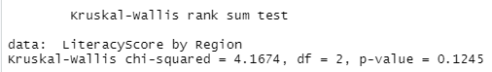

* Test Value = 4.17
* P-Value = .12

**Make the decision.**

* Test Value (4.17) < Critical Value (5.99)
* P-Value (.12) > α (.05)
* Fail to reject the null hypothesis

**Summarize the results.**

Through the OECD, 15-year-olds are tested in various subjects. Their math scores in 3 regions were randomly selected. We used the Kruskal Wallis test to see if there is a difference in mean math scores. Since we failed to reject the null hypothesis, we can conclude that there is no difference in scores between the regions.

Section 13-6 Question 6

Subway and Commuter Rail Passengers

**State the hypotheses and identify the claim.**

H0: ρ = 0 (*No relationship between subway and commuter rail trips)*

Ha: ρ ≠ 0 (Claim) (*Relationship between subway and commuter rail trips)*

**Find the critical value(s).**

* α = .05
* n = 6
* Two-Tailed Test
* Critical Value = .89 (Rank Correlation Coefficient Table)

**Compute the test value.**

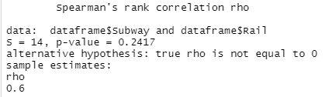

* Test Value = .6
* P-Value = .24

**Make the decision.**

* Test Value (.6) < Critical Value (.89)
* P-Value (.24) > α (.05)
* Fail to reject the null hypothesis

**Summarize the results.**

Six cities are randomly selected and the number of daily passenger trips for subways and commuter rail service is obtained. We ran a Spearman Correlation Coefficient test to see if there is a relationship between subway and commuter rail trips. Since we failed to reject the null hypothesis, we can conclude that there is linear relationship between subway and commuter rail trips. Since our ρ is positive, we can say that this linear relationship is positive. As one variable increases, the other variable increases.

Conclusion

Even though the problems guided us to using nonparametric methods, I still double-checked that non parametric tests were the right tests to use. I created Q-Q plots in order to see if our samples came from normally distributed datasets.

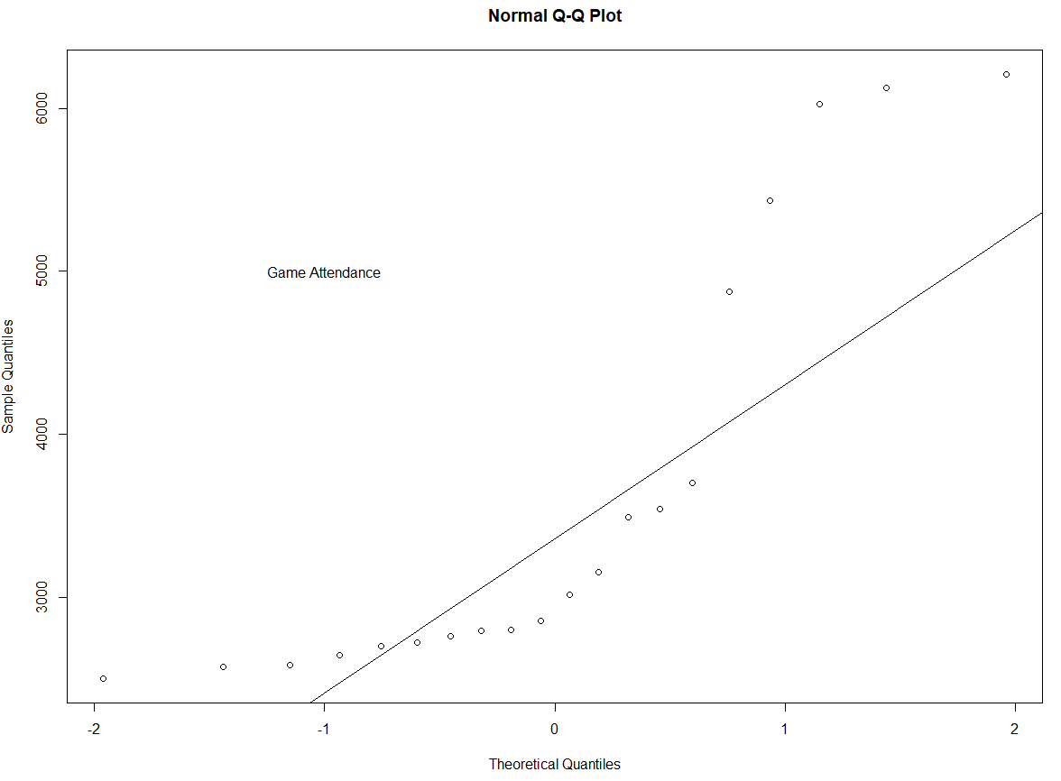 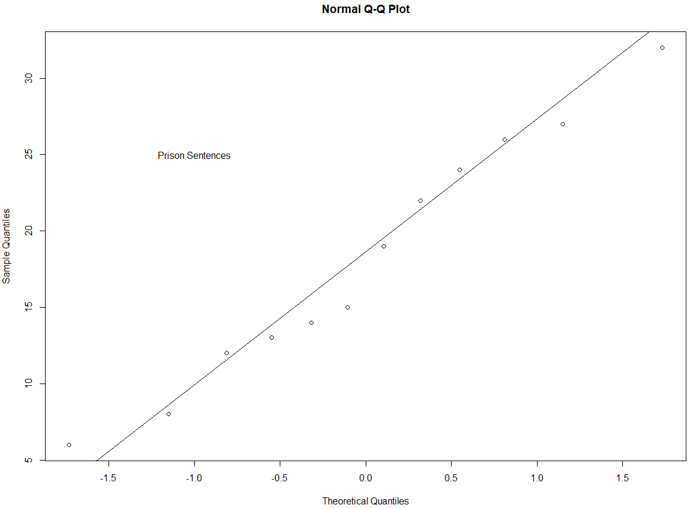

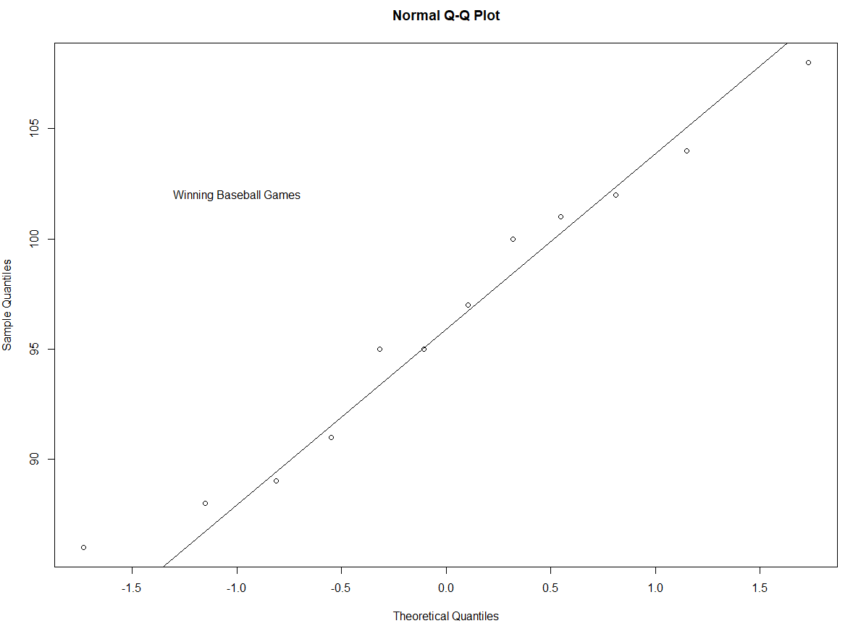

Since points on these charts do not fall on the line, we can generally say that our samples in the various problems do not come from normally distributed datasets or have small sample sizes. We used the Sign Test, Wilcoxon Rank Sum Test, the Kruskal-Wallis test, and Spearman’s Rank Order Correlation Coefficient, to accept or reject various statistical claims in the null or alternative hypotheses. Since these tests were run on data from datasets not normally distributed or have small sample sizes, the threshold for rejecting the null hypotheses was much higher than those generally of parametric tests. These results would have changed if we used parametric tests, but regardless, our findings in each problem were statistically legitimate.

Citations

Bujang, Mohamad Adam, and Fatin Ellisya Sapri. “An Application of the Runs Test to Test for Randomness of Observations Obtained from a Clinical Survey in an Ordered Population.” *The Malaysian Journal of Medical Sciences : MJMS*, Penerbit Universiti Sains Malaysia, July 2018, https://www.ncbi.nlm.nih.gov/pmc/articles/PMC6422539/.

“Home.” *Statistics Online Support*, http://sites.utexas.edu/sos/guided/inferential/numeric/bivariate/rankcor/.

“Kruskal Wallis H Test: Definition, Examples, Assumptions, SPSS.” *Statistics How To*, https://www.statisticshowto.com/probability-and-statistics/statistics-definitions/kruskal-wallis/.

“Nonparametric Tests.” *Mann Whitney U Test (Wilcoxon Rank Sum Test)*, https://sphweb.bumc.bu.edu/otlt/mph-modules/bs/bs704_nonparametric/bs704_nonparametric4.html.

“Nonparametric Tests.” *Wilcoxon Signed Rank Test*, https://sphweb.bumc.bu.edu/otlt/mph-modules/bs/bs704_nonparametric/BS704_Nonparametric6.html.

“Spearman Rank Correlation (Spearman's RHO): Definition and How to Calculate It.” *Statistics How To*, 1 July 2021, https://www.statisticshowto.com/probability-and-statistics/correlation-coefficient-formula/spearman-rank-correlation-definition-calculate/.

“Spearman's Rank-Order Correlation (Cont...).” *Spearman's Rank-Order Correlation - A Guide to How to Calculate It and Interpret the Output.*, https://statistics.laerd.com/statistical-guides/spearmans-rank-order-correlation-statistical-guide-2.php.

*Statistical Tables*, https://www.york.ac.uk/depts/maths/tables/.

Stephanie. “Sign Test: Step by Step Calculation.” *Statistics How To*, 31 Dec. 2020, https://www.statisticshowto.com/sign-test/.

Appendix

#Question 6#

#sign test single sample#

attendance <- c(6210,3150,2700,3012,4875,3540,6127,2581,2642,2573,2792,

2800,2500,3700,6030,5437,2758,3490,2851,2720)

qqnorm(attendance)

qqline(attendance) #on straight line means normal distribution#

text(-1,5000,"Game Attendance")

#H0: median = 3000#

#Ha: median notequal to 3000#

mediandiff <- attendance-3000

mediandiff

positive <- length(mediandiff[mediandiff>0])

negative <- length(mediandiff[mediandiff<0])

positive

negative

#n=20,alpha=.05, twotailed test so CV (from table) = 5

#test value = 10#

signtestss <- binom.test(x=c(positive,negative),alternative="two.sided")

signtestss

signtestss$statistic #test value#

signtestss$p.value #p-value#

#test value > cv AND p-value > alpha#

#fail to reject the null#

#Question 10#

#sign test single sample#

#alpha = .05#

#n=40#

#one tailed#

#median=200#

#H0: median = 200#

#Ha: median <200 (claim)#

#15 days less than 200, 25 days =>200#

#since n>25, use z formula to calculate test value = -1.64#

n <- 40

X <- 15

#Test Value#

z <- ((X+.5)-(.5*n))/((sqrt(n)/2))

z

#test value < critical value, fail to reject null#

#Question 4#

#wilcox rank sum#

males <- c(8,12,6,14,22,27,32,24,26,19,15,13)

females <- c(7,5,2,3,21,26,30,9,4,17,23,12,11,16)

qqnorm(males)

qqline(males)

text(-1,25,"Prison Sentences")

qqnorm(females)

qqline(females)

#H0: no difference in prison sentence length by gender (claim)#

#Ha: difference in prison length by gender#

#alpha = .05, two-tailed test, cv = 1.96 & -1.96#

wilctest <- wilcox.test(x=males,y=females,alternative="two.sided",correct = FALSE)

wilctest

#teststat = 113, pvalue =.13#

#fail to reject null#

#Question 8#

AL <- c(108,86,91,97,100,102,95,104,95,89,88,101)

NL <- c(89,96,88,101,90,91,92,96,108,100,95)

qqnorm(AL)

qqline(AL)

text(-1,102,"Winning Baseball Games")

qqnorm(NL)

qqline(NL)

#H0: no difference in wins by league#

#Ha: difference in wins by league (claim)#

#alpha = .05, two-tailed test, cv = 1.96 & -1.96#

wilctestbb <- wilcox.test(x=AL,y=NL,alternative="two.sided",correct = FALSE)

wilctestbb

#teststat = 73, pvalue =.67#

#fail to reject null#

#Question 2#

WestHem <- data.frame(LiteracyScore=c(527,406,474,381,411),Region=rep("Western Hemisphere",5))

Europe <- data.frame (LiteracyScore=c(520,510,513,548,496),Region=rep("Europe",5))

EastAsia <- data.frame(LiteracyScore=c(523,547,547,391,549),Region=rep("Eastern Asia",5))

table <- rbind(WestHem,Europe,EastAsia)

table

#H0: no difference in mean mathematics literacy scores among the 3 different regions

#Ha: difference in mean mathematics literacy scores among the 3 different regions (Claim)

#alpha = .05#

#df =Number of groups-1 = k-1 = 3-1 =2#

#Chi-Square table CV = 5.991

TestV <- kruskal.test(LiteracyScore ~ Region ,data=table)

TestV

#test value = 4.17#

#pvalue=.12#

#fail to reject null#

#question 6#

city <- c(1,2,3,4,5,6)

subway <- c(845,494,425,313,108,41)

rail <- c(39,291,142,103,33,38)

dataframe <- data.frame(City=city,Subway=subway,Rail=rail)

dataframe

#The most common null hypothesis is H0: ρ = 0 which indicates there is no linear relationship between x and y in the population#

#H0: p=0#

#Ha: p not equal to 0#

#n=6, alpha=.05, twosided#

#CV = .89 from rank correlation coefficient cv table#

TestV2 <- cor.test(dataframe$Subway,dataframe$Rail,method = "spearman")

TestV2

#testvalue=.6, pvalue=.24#

#fail to reject null#